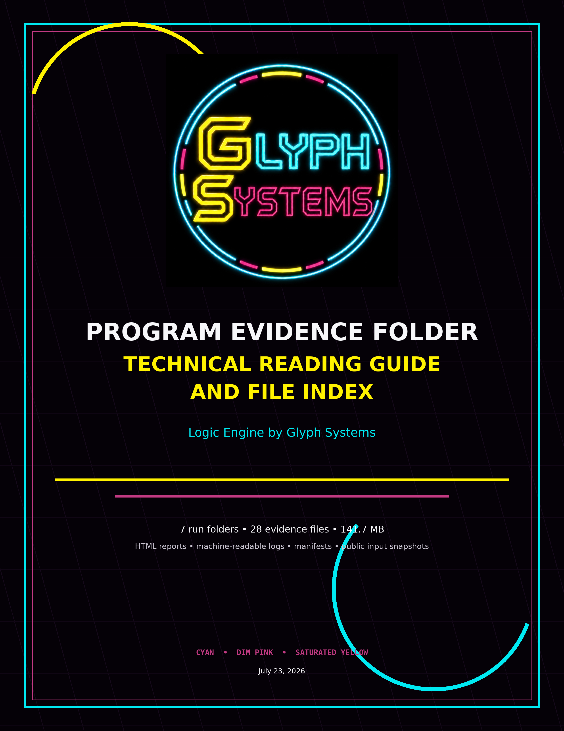

Program Evidence Folder — Technical Overview
What is inside PROGRAMS DOC INFO, how the files relate, and which records are final, milestone, or startup-only.
Purpose. This document is the standalone reading guide for the program evidence folder. It allows a reviewer to understand the directory without opening the interactive portfolio and establishes a clean path from human-readable reports to machine-readable evidence.
Package summary. The folder contains 7 run directories, 28 files, and approximately 141.7 MB of preserved evidence. Programs 36, 38, and 40 contain both twelve-hour milestone exports and completed long-duration final exports. Programs 41 and 42 contain valid twelve-hour milestone records for continuing live runs, plus separate startup/preflight exports that ended before a completed round.
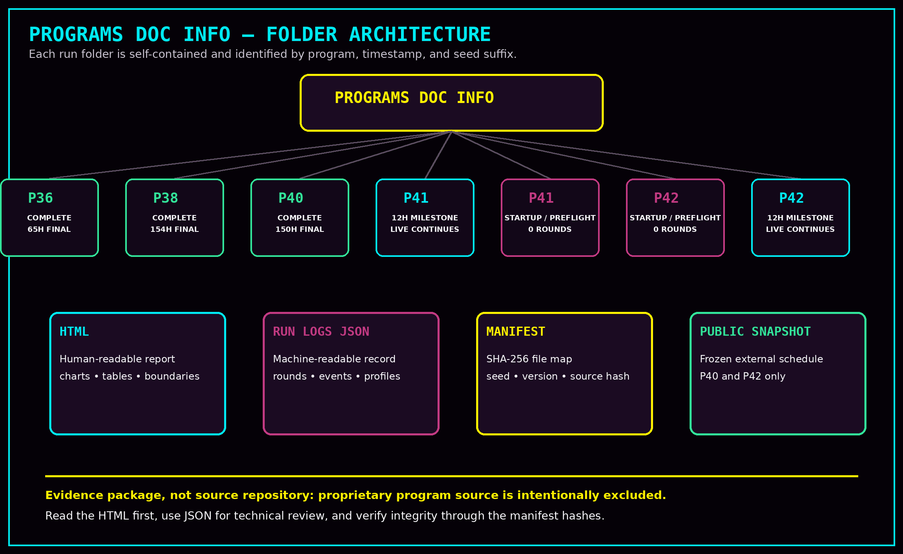
This is an evidence package, not a source-code repository. The proprietary program source is intentionally excluded while source hashes and evidence hashes are preserved.

1. How the Files Work Together
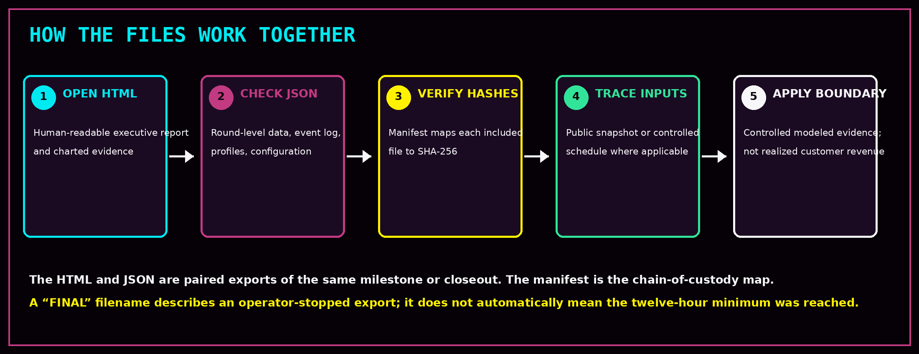

The folder is designed for layered review:
- Investor Evidence HTML is the first reading layer: executive result, charts, distribution, controller comparison, evidence boundary, and interpretation.
- Run Logs JSON is the technical layer: complete rounds, event logs, profile schedules, cost coefficients, configurations, source hashes, evidence payload hashes, and export metadata.
- Package Manifest JSON is the integrity layer: program identity, version, master seed, source-code inclusion status, source SHA-256, and a SHA-256 map for every packaged evidence file.
- Public Incident Snapshot JSON is the external-input layer for public-incident-driven programs. It freezes the provider records and schedule used by the run.
Paired HTML and RUN_LOGS files describe the same export moment. A twelve-hour milestone and a later final export are separate preserved records, not replacements for one another.

2. Folder and Filename Anatomy
Element | Meaning
PROGRAM_36 | Program family and test lane.
RUN_20260714-163251 | Run creation date and time component.
14b41334946e2bae | Unique seed/run suffix used to distinguish one execution from another.
12H_MILESTONE | Export created when the predeclared twelve-hour / 72-round minimum was reached.
FINAL | Operator-stopped closeout export. Always check runtime, completed rounds, and minimum_reached; “FINAL” does not automatically mean the minimum was completed.
INVESTOR_EVIDENCE.html | Human-readable browser report.
RUN_LOGS.json | Machine-readable evidence record.
PACKAGE_MANIFEST.json | Cryptographic file map and package metadata.
PUBLIC_INCIDENT_SNAPSHOT.json | Frozen public incident input record used by Programs 40 and 42.

Critical rule: use runtime and completed-round count to classify an export. The two startup/preflight “FINAL” files have zero completed rounds and must not be presented as long-horizon outcome evidence.

3. Program Status Map
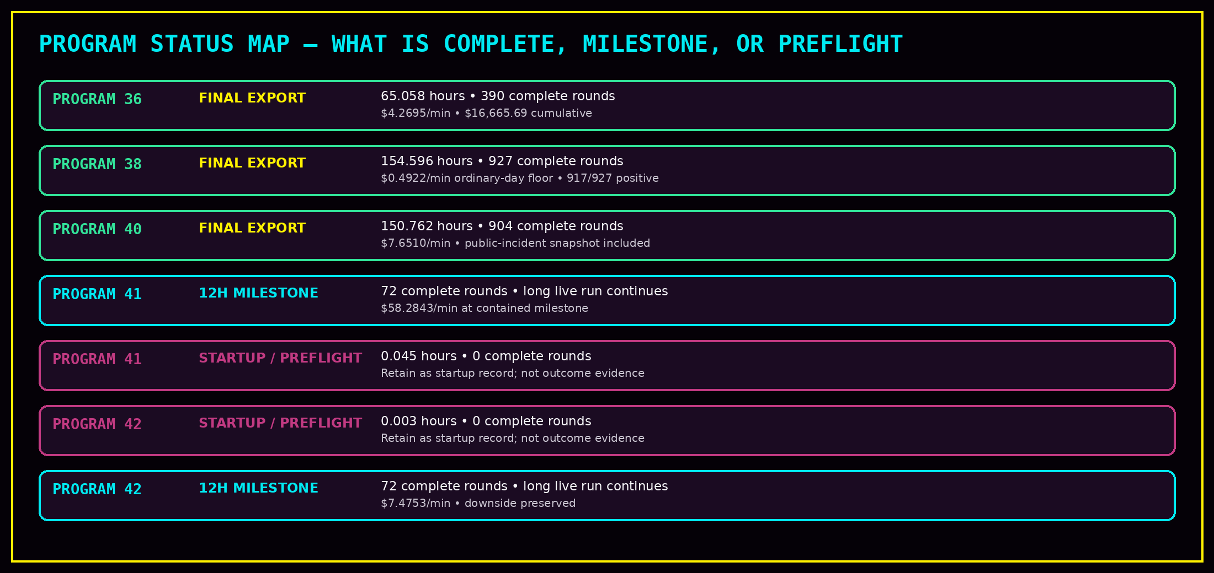
Programs 41 and 42 have two separate run IDs because a short startup execution and the continuing long-duration execution were different runs. The startup records remain useful as preflight history, but the twelve-hour milestone folders carry the meaningful contained evidence. The later witnessed shutdown and final exports for the continuing runs are not yet present in this package.

4. Program 36 — Small Payment Processor Continuous Run
Program 36 models a conservative small-payment-processor environment. The folder preserves a twelve-hour milestone and a later operator-stopped final export from the same master seed.
Export | Runtime | Rate | Cumulative | Interpretation
12H milestone | 12.000 h / 72 rounds | $4.0382/min | $2,907.50 | Minimum reached; early long-horizon checkpoint.
Final | 65.058 h / 390 rounds | $4.2695/min | $16,665.69 | Completed long-duration small-processor evidence. Median $0.8609/min; worst $0.0289/min.
- Use the final HTML for the complete long-duration executive view.
- Use the final RUN_LOGS JSON for round-level review and exact controller totals.
- Use the manifest to verify the milestone and final HTML/JSON hashes.
- The dollar values are full modeled operational savings before any commercial allocation.
Program 36 is final controlled evidence, not realized customer revenue and not private data from a named processor.

5. Program 38 — Ordinary-Day Payment Processor Floor Run
Program 38 intentionally removes burst-saturation rounds and tests the ordinary-day floor. Its purpose is to show whether the signal survives mostly low, moderate, and ordinary high conditions rather than relying on extreme incidents.
Export | Runtime | Rate | Positive | Worst | Interpretation
12H milestone | 12.000 h / 72 | $0.5099/min | 71 / 72 | -$0.0002/min | Ordinary-day minimum reached.
Final | 154.596 h / 927 | $0.4922/min | 917 / 927 | -$0.0003/min | Long-duration lower-bound evidence; cumulative $4,565.70.
- The final median was $0.3853/min and the tenth percentile was $0.0701/min.
- The nearly zero negative worst round is preserved and should not be hidden.
- The folder contains paired milestone and final HTML/JSON records plus a manifest.
Program 38 should be read as lower-bound endurance evidence, not as the highest-value lane.

6. Program 40 — Public Incident-Driven Medium Financial Run
Program 40 uses a frozen snapshot of official public incident records to shape the severity schedule for a controlled medium-financial workload. The snapshot influences the run schedule; it does not reproduce provider-private traffic, losses, or recovery systems.
Export | Runtime | Rate | Positive | Cumulative | Interpretation
12H milestone | 12.000 h / 72 | $7.9580/min | 71 / 72 | $5,729.77 | Minimum reached; public schedule frozen.
Final | 150.762 h / 904 | $7.6510/min | 902 / 904 | $69,208.45 | Completed long-duration public-incident evidence.
- The final median was $1.9898/min and the worst round remained -$0.0442/min.
- The PUBLIC_INCIDENT_SNAPSHOT JSON should be retained beside the report and logs.
- The manifest hashes the milestone report, final report, both log files, and the public incident snapshot.
- The historical report displays an illustrative 35% Glyph Systems cut. That display is preserved unchanged as part of the evidence history; current commercial terms are documented separately.
Program 40 is external-input-shaped controlled evidence. Public incidents provide a reproducible schedule, not customer production data.

7. Program 41 — High-Volume Payment Network Recovery Challenge
Program 41 represents a compressed high-volume payment-network workload. The meaningful folder in this package is the twelve-hour milestone run. A second short run was operator-stopped after approximately 0.045 hours with zero completed rounds.
Record | Runtime | Rate | Positive | Cumulative | Correct classification
12H milestone | 12.000 h / 72 | $58.2843/min | 72 / 72 | $41,964.71 | Valid milestone evidence; live run continued beyond this export.
Startup final | 0.045 h / 0 | $2.3154/min | 0 / 0 | $6.18 | Preflight/startup record only; no completed-round outcome.
- The twelve-hour milestone median was $8.8897/min and the worst completed round was $1.3129/min.
- The milestone report shows an illustrative 50% commercial split for planning only.
- The startup folder is useful for provenance and troubleshooting history but should be labeled clearly in the browser.
- The final witnessed closeout of the continuing live run will become a new export package later.
Do not combine the startup run and the twelve-hour run as though they share one continuous seed. They are separate executions with separate run IDs.

8. Program 42 — High-Value Treasury and Cross-Border Payout Recovery
Program 42 models lower-count, higher-value treasury, settlement, payroll, remittance, marketplace payout, and cross-border recovery conditions. As with Program 41, the package contains a startup/preflight run and a separate twelve-hour milestone run.
Record | Runtime | Rate | Positive | Cumulative | Correct classification
Startup final | 0.003 h / 0 | $0.0000/min | 0 / 0 | $0.00 | Preflight/startup record only; no completed-round outcome.
12H milestone | 12.000 h / 72 | $7.4753/min | 45 / 72 | $5,382.21 | Valid milestone evidence; live run continued beyond this export.
- The milestone median was $1.6210/min, the tenth percentile was negative, and the worst round was -$3.3787/min.
- The downside is important evidence: Program 42 was not positive in every round.
- Both run folders contain a public incident snapshot because the schedule was frozen from external public records.
- The startup manifest belongs only to the startup run. It is not a manifest for the later twelve-hour milestone run.
Program 42 demonstrates a positive aggregate milestone with material downside. It should be presented with the full distribution, not only the average.

9. Complete Folder Inventory
Pgm | Run folder | Files | Size | Contained record
36 | PROGRAM_36_RUN_20260714-163251-14b41334946e2bae | 5 | 29.5 MB | 12H + final HTML/JSON; manifest
38 | PROGRAM_38_RUN_20260714-181842-858c414ad996d313 | 5 | 37.5 MB | 12H + final HTML/JSON; manifest
40 | PROGRAM_40_RUN_20260714-213950-8ab9a1aa8917edf4 | 6 | 64.4 MB | 12H + final HTML/JSON; manifest; public snapshot
41 | PROGRAM_41_RUN_20260717-131333-7230266afb3fee48 | 2 | 4.8 MB | 12H milestone HTML/JSON
41 | PROGRAM_41_RUN_20260717-131348-a94123fef946a2de | 3 | 0.1 MB | startup final HTML/JSON; manifest
42 | PROGRAM_42_RUN_20260717-131457-3156ee6e2e5c0e7f | 4 | 0.3 MB | startup final HTML/JSON; manifest; public snapshot
42 | PROGRAM_42_RUN_20260717-131602-2d54d7dcdee6e5ca | 3 | 5.0 MB | 12H milestone HTML/JSON; public snapshot

File count by type
- Investor Evidence HTML: 10
- Run Logs JSON: 10
- Package Manifest JSON: 5
- Public Incident Snapshot JSON: 3
Total contained evidence: 28 files across 7 run folders, approximately 141.7 MB.

10. Integrity, Hashes, and Chain of Custody
The manifests preserve a cryptographic map of the evidence package. Each listed file is associated with a SHA-256 digest. A reviewer can recompute the digest and compare it with the manifest to check whether the file has changed.
Manifest field | Purpose
created_utc | When the package manifest was created.
included_files | Filename-to-SHA-256 map for the evidence files.
master_seed | Unique identifier tying the package to one execution.
program / version | Human-readable program identity and program version.
source_code_included: false | Confirms that the evidence package does not expose the proprietary source.
source_sha256 | Hash of the program source used for the run, allowing controlled internal verification without publishing the source.
evidence_payload_sha256 | Hash recorded in the run logs for the exported evidence payload.

- Never edit an original HTML, JSON, snapshot, or manifest in place after export.
- If an explanatory label is needed, add a separate README document rather than altering the evidence file.
- Preserve startup, milestone, and final exports as separate historical records.
- When a new final export is created for Programs 41 or 42, add the entire new package rather than overwriting the milestone folder.
The manifest protects file integrity; it does not independently validate the economic model or customer applicability. Those require technical review and authorized real-data testing.

11. Reviewer Paths — Two Minutes, Ten Minutes, or Technical Due Diligence

Two-minute orientation
- Read this document’s program status map.
- Open the final HTML for Programs 36, 38, and 40.
- Open the twelve-hour milestone HTML for Programs 41 and 42.
- Do not treat the zero-round startup files as results.

Ten-minute evidence review
- Read the executive result and evidence boundary in each selected HTML.
- Compare runtime, completed rounds, median, worst round, positive-round count, and cumulative modeled value.
- Check the milestone-to-final continuity for Programs 36, 38, and 40.
- Open the public incident snapshot for Program 40 and the valid Program 42 milestone.

Technical due diligence
- Inspect RUN_LOGS JSON for full round arrays, controller totals, event logs, profiles, configuration, and export metadata.
- Recompute SHA-256 hashes and compare them with each package manifest.
- Confirm master seed, source SHA-256, evidence payload SHA-256, started_utc, ended_utc, export_kind, and minimum_reached.
- Review the preserved program source privately under the appropriate confidentiality and trade-secret controls.
- Repeat the method in an authorized read-only customer shadow pilot using pre-agreed measurement rules.

12. Correct Evidence Boundaries and Historical Display Notes
Boundary | Correct interpretation
Modeled values | Controlled estimates of avoided operational friction under the declared test rules; not realized cash or collected revenue.
Named companies | The runs do not claim access to named private payment, banking, treasury, or network systems.
Public incidents | External records shape a frozen schedule; they do not reproduce provider-private traffic or losses.
Commercial percentage | Program 40 preserves a historical illustrative 35% display. Programs 41 and 42 use an illustrative 50% display. Current terms are governed by separate commercial documents.
Final filename | Means operator-stopped export. Check minimum_reached and completed rounds before calling it final evidence.
Source code | Intentionally excluded from the public evidence package. Source hashes preserve a verification handle without exposing the protected core.
Customer claim | The next commercial gate is independent review and an authorized read-only customer shadow pilot.
Core conclusion: this folder preserves repeatable controlled signals, long-duration continuity, distributions that include downside, and traceable evidence packages. It does not claim guaranteed customer savings.

13. Final Reviewer Checklist
Check | Question
Run identity | Did I confirm program number, run folder, master seed, and timestamps?
Export type | Is this a twelve-hour milestone, a true long-duration final, or a zero-round startup/preflight export?
Minimum | Does minimum_reached equal true, and how many complete rounds exist?
Distribution | What do the median, lower tail, worst round, and positive-round count show?
Pairing | Am I reading the HTML and RUN_LOGS JSON from the same run and export moment?
Integrity | Does a manifest exist, and do the file hashes match?
Inputs | Is there a public incident snapshot or controlled schedule that must travel with the report?
Commercial display | Is the displayed percentage historical or illustrative rather than contractual?
Evidence boundary | Am I keeping the conclusion within controlled modeled testing?
Next gate | What requires independent review or authorized customer data?

Final interpretation
PROGRAMS DOC INFO is the deeper technical evidence layer behind the interactive portfolio. It preserves the human-readable reports, machine-readable logs, integrity manifests, and frozen public-input records needed to move from a visual claim to a reviewable evidence chain.
Programs 36, 38, and 40 are the completed long-duration packages in this folder. Programs 41 and 42 currently contribute valid twelve-hour milestones for continuing live runs. Their separate zero-round startup exports remain part of the historical record but are not outcome evidence.

